<https://us3.ca.analytics.ibm.com/bi/?perspective=explore&pathRef=.my_folders%2FNew%2Bexploration%2B1&subView=model000001837a471bd1_00000000>

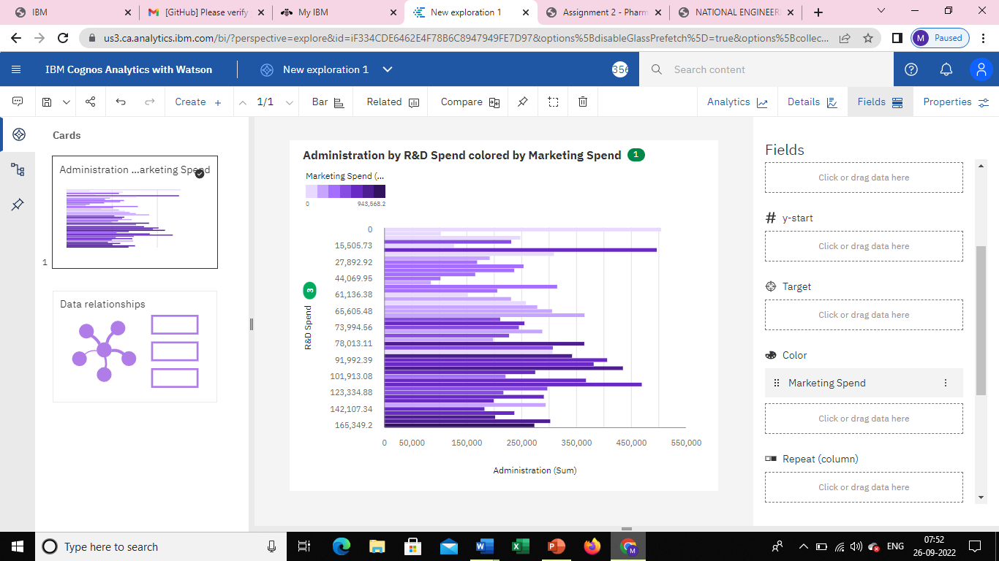

<https://us3.ca.analytics.ibm.com/bi/?perspective=explore&pathRef=.my_folders%2FNew%2Bexploration%2B2&subView=model000001837a4918c7_00000003>

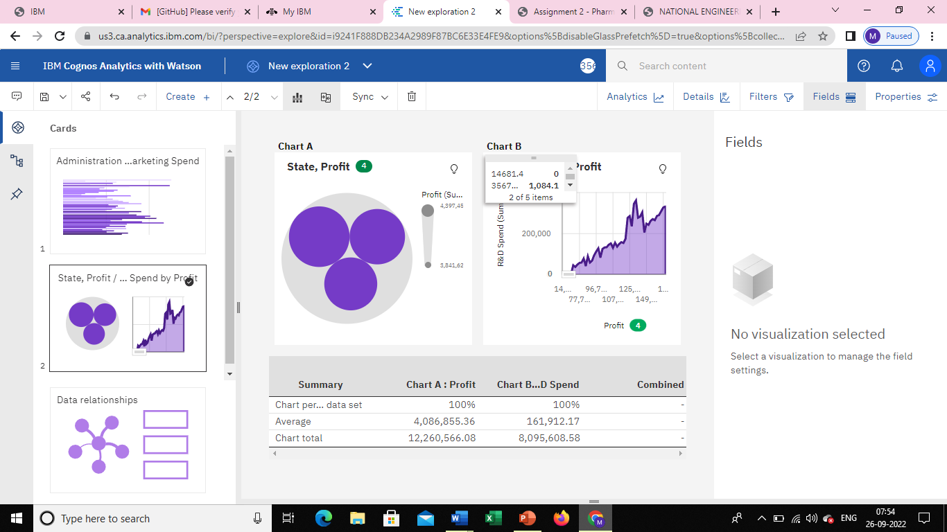

<https://us3.ca.analytics.ibm.com/bi/?perspective=explore&pathRef=.my_folders%2FNew%2Bexploration%2B3&subView=model000001837a4ad835_00000004>

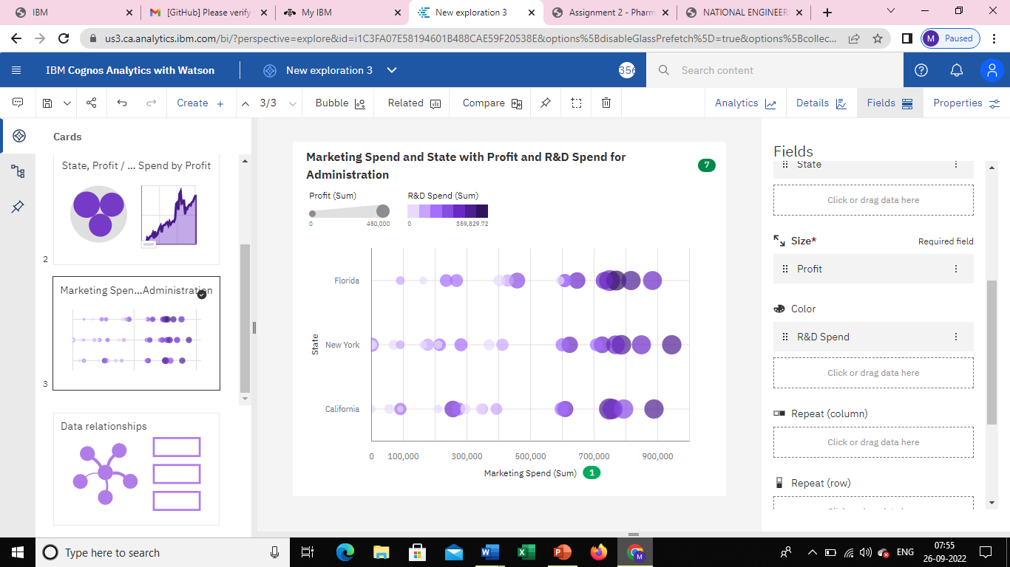

<https://us3.ca.analytics.ibm.com/bi/?perspective=explore&pathRef=.my_folders%2FNew%2Bexploration%2B4&subView=model000001837a4c849b_00000002>

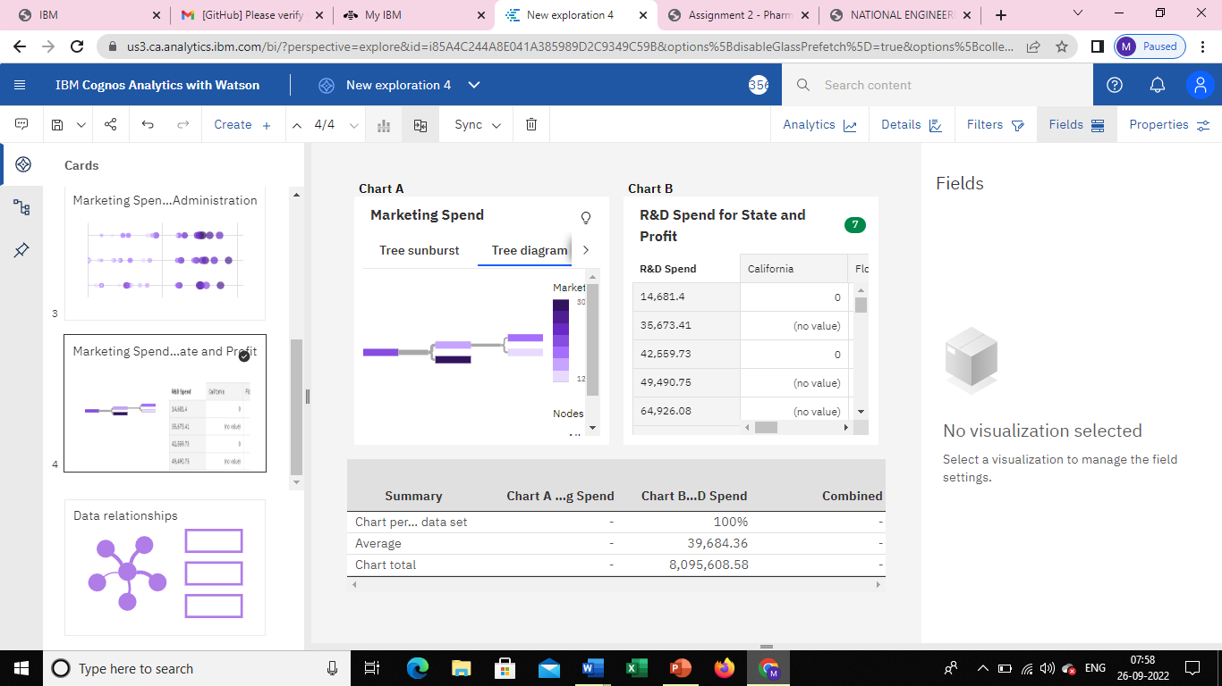

<https://us3.ca.analytics.ibm.com/bi/?perspective=explore&pathRef=.my_folders%2FNew%2Bexploration%2B5&subView=model000001837a4e4b34_00000004>

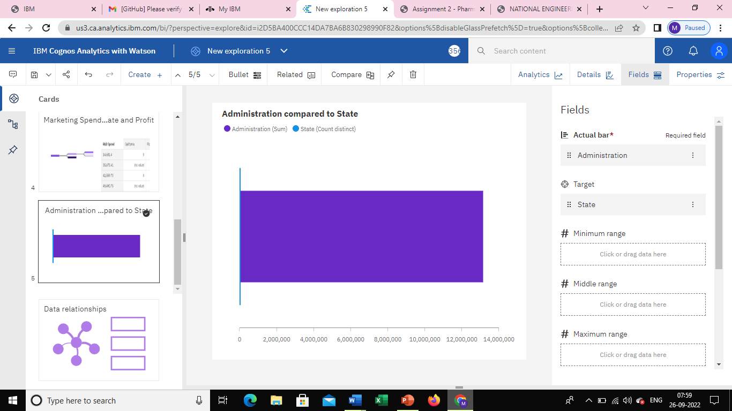

<https://us3.ca.analytics.ibm.com/bi/?perspective=explore&pathRef=.my_folders%2FNew%2Bexploration%2B6&subView=model000001837a4f7ac4_00000001>

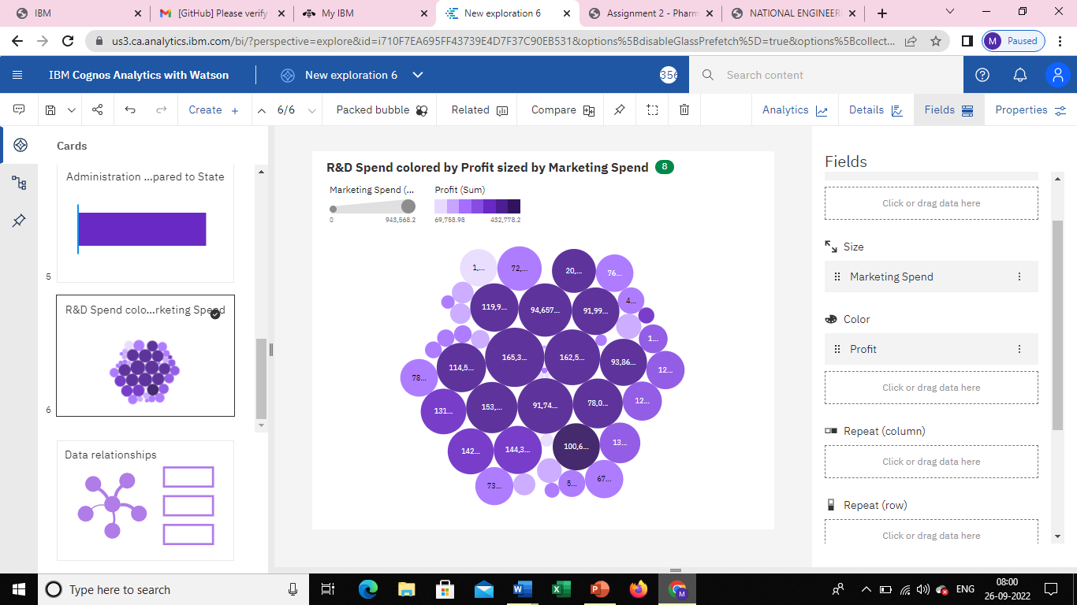

<https://us3.ca.analytics.ibm.com/bi/?perspective=explore&pathRef=.my_folders%2FNew%2Bexploration%2B7&subView=model000001837a50b1bb_00000000>

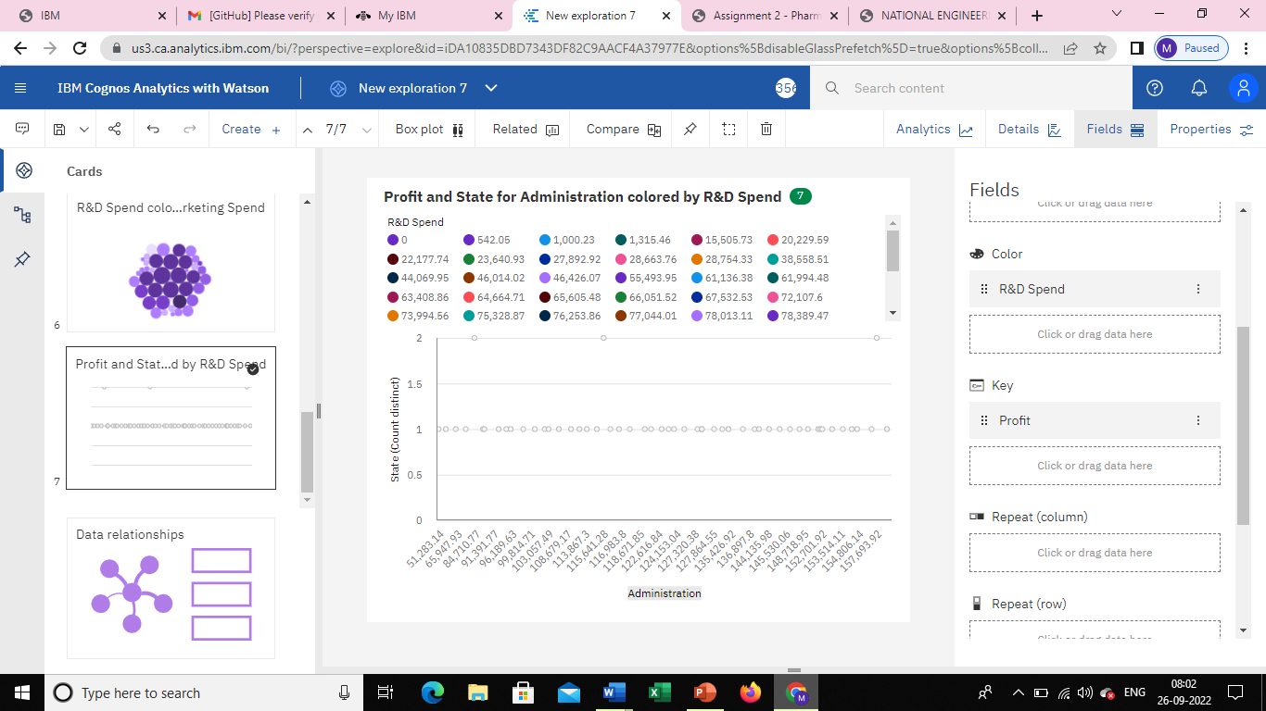

<https://us3.ca.analytics.ibm.com/bi/?perspective=explore&pathRef=.my_folders%2FNew%2Bexploration%2B8&subView=model000001837a524f35_00000002>

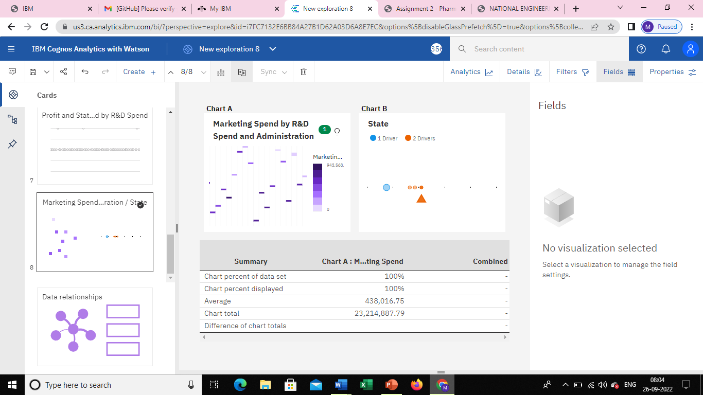

<https://us3.ca.analytics.ibm.com/bi/?perspective=explore&pathRef=.my_folders%2FNew%2Bexploration%2B9&subView=model000001837a53da0b_00000003>

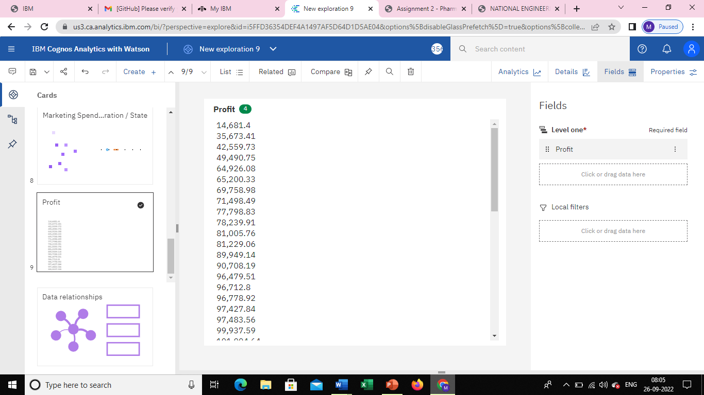

<https://us3.ca.analytics.ibm.com/bi/?perspective=explore&pathRef=.my_folders%2FNew%2Bexploration%2B10&subView=model000001837a54f17a_00000004>

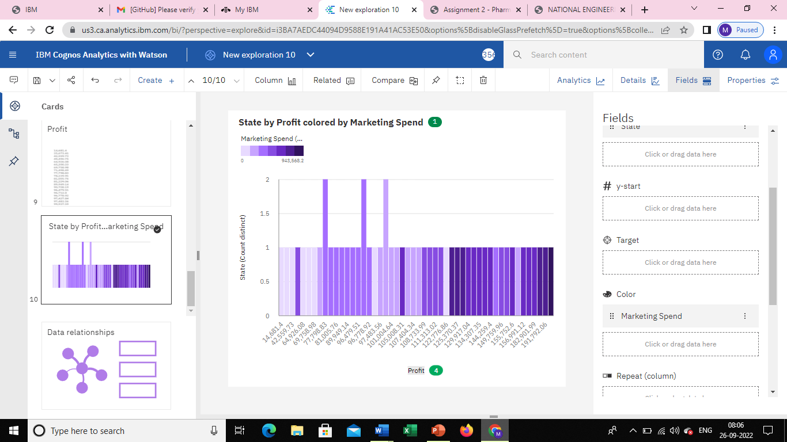

<https://us3.ca.analytics.ibm.com/bi/?perspective=explore&pathRef=.my_folders%2FNew%2Bexploration%2B11&subView=model000001837a564426_00000003>

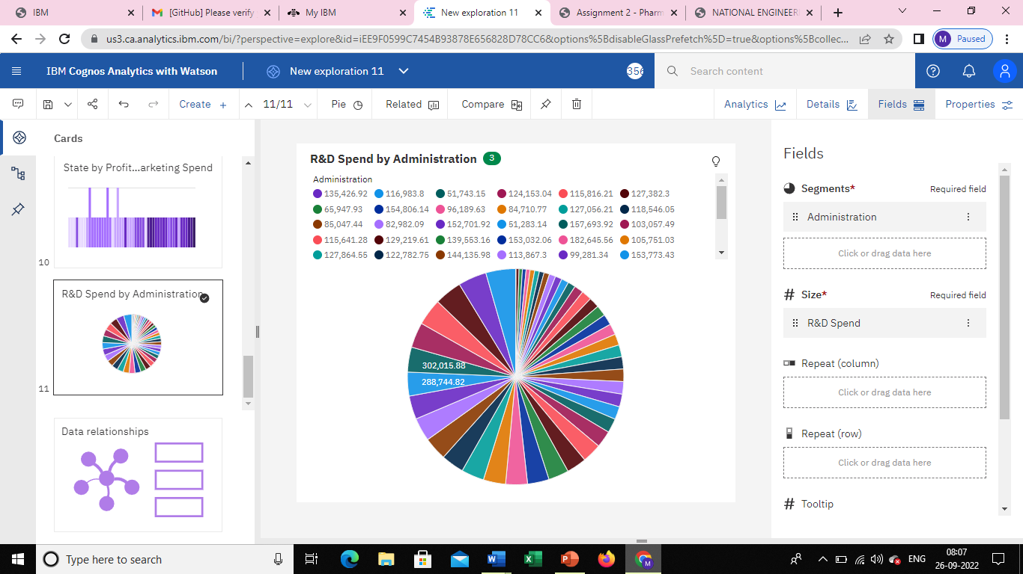

<https://us3.ca.analytics.ibm.com/bi/?perspective=explore&pathRef=.my_folders%2FNew%2Bexploration%2B12&subView=model000001837a5776ba_00000004>

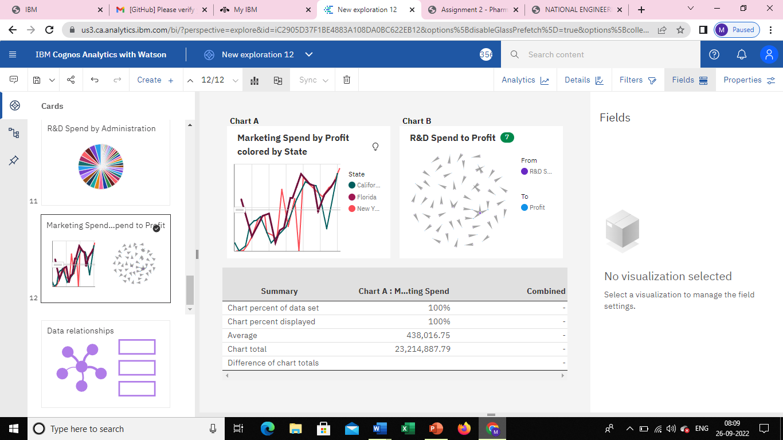

<https://us3.ca.analytics.ibm.com/bi/?perspective=explore&pathRef=.my_folders%2FNew%2Bexploration%2B13&subView=model000001837a5952e5_00000000>

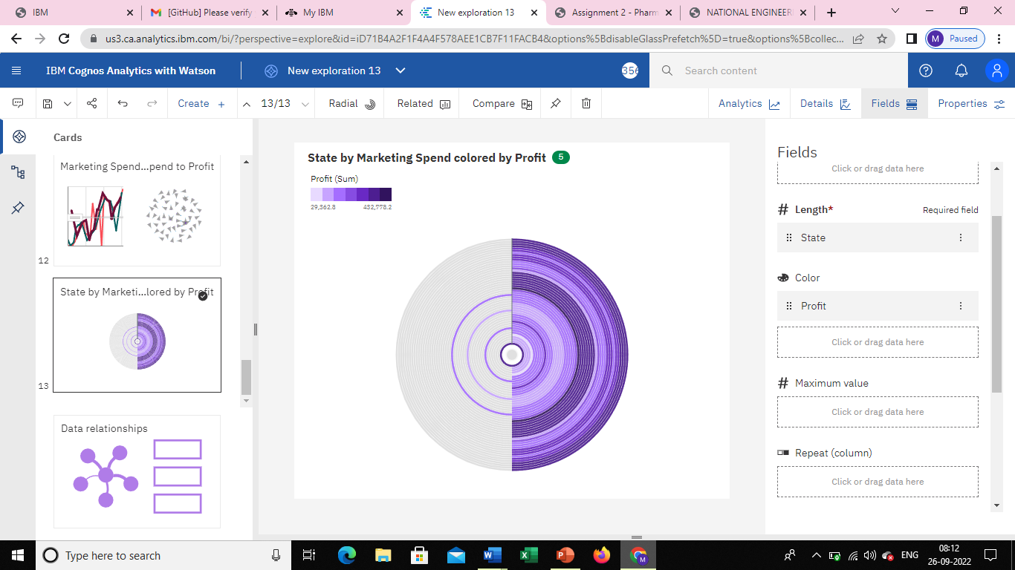

<https://us3.ca.analytics.ibm.com/bi/?perspective=explore&pathRef=.my_folders%2FNew%2Bexploration%2B14&subView=model000001837a5b7ad5_00000000>

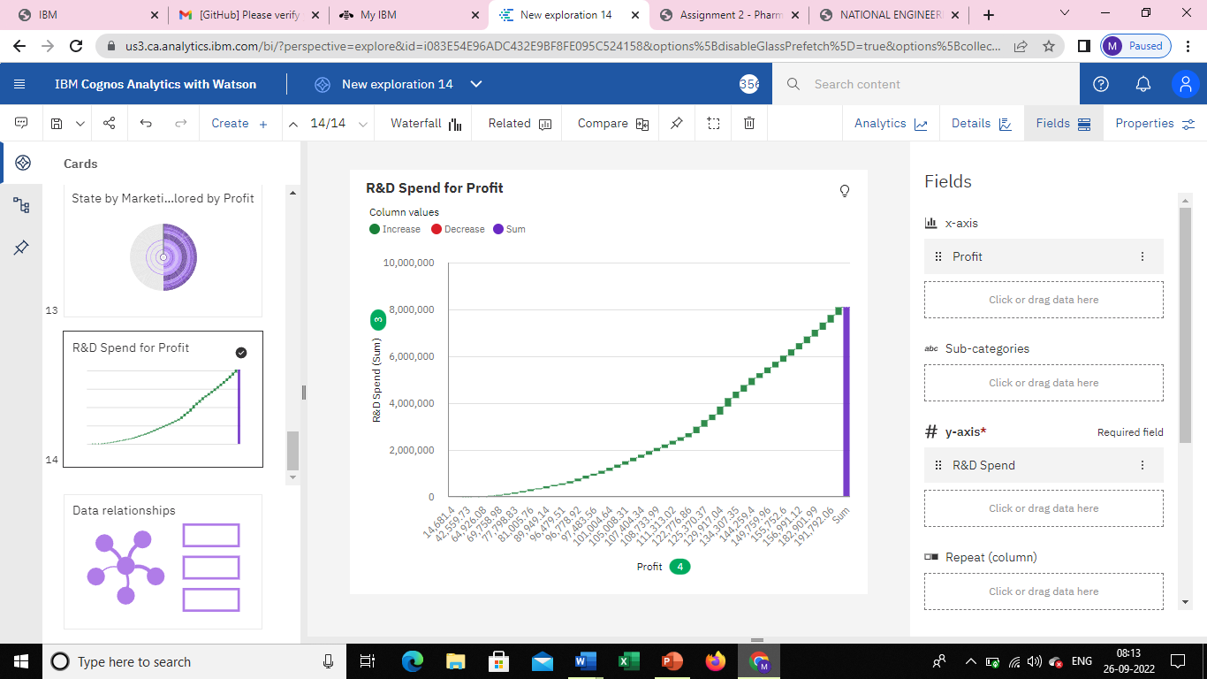

<https://us3.ca.analytics.ibm.com/bi/?perspective=explore&pathRef=.my_folders%2FNew%2Bexploration%2B15&subView=model000001837a5c87c9_00000000>

